**School Of Information Technology**

**IT2553 DSA**

|  |  |
| --- | --- |
| **Admin No & Team Members Name:** | 201520M: Eden Will Sng Jin Xuan |
| **PEM Group:** | SF2102 |
| **Module:** | IT2553-02 |
| **Assignment:** | Tutorial 09 |

1)

Start + cellsize * index

Memory address of the cell 4 of the above array

2146 + 2 * 4 = 2154

Each cell takes 2 bytes hence it is 2 * 4

Memory address is the starting address of the cell

Cell size is not always 2 it depends on the data!

2

Refer to the python program

3

Referential array can have mixed types

Compact array does not allow for different types

Referential arrays have the address of the number

Size of individual elements in the array can vary

Memory address is 64 bits!

Address are in the list, the actual number is somewhere else

List store the address

By the way please draw the diagram.

Temp = primes[3:6]

Ans 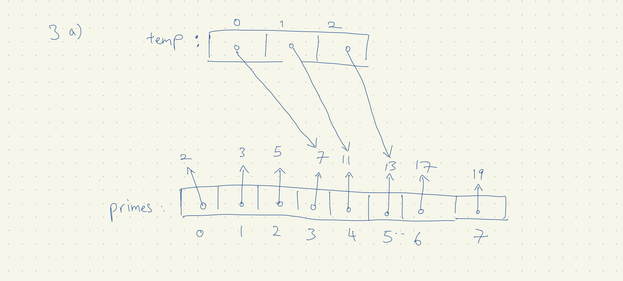A new array Temp is created. Temp array points to 7,11,13

It does not include primes[6] due to how python array works [ Start , Stop )

prime gives the pointer to refer to these numbers 2,3,5,7,11,17,19

b)

temp[2] = 15

temp array will output these numbers [7,11,15]

the index pointing to 13 from 3A is replaced for 15 due to the temp[2] = 15

prime still outputs [2,3,5,7,11,17,19]

c)

counters = [0] * 8

counter array will output

[0,0,0,0,0,0,0,0,0]

Counters[2] += 1

Is counter[2] == 1

Therefore the resulting array is [0,0,1,0,0,0,0,0]